Tripod Mobile Phone/Camera Holder with Light.

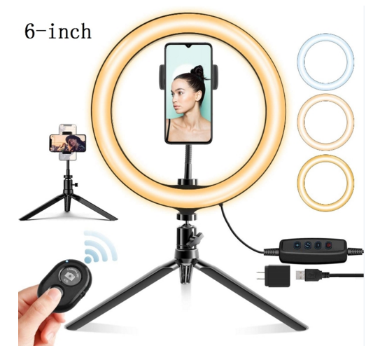

Tripod with light Mobil Phone holder
Price £ 12.50/pc minimum quantity 1800

